SIMATS ENGINEERING
CSA6303- Threat Intelligence and Network Security
A1-Malware Analysis Assignment
Assessment Questions
Subject | Threat Intelligence | Total Marks | 30
Questions | 3 (all compulsory) | Marks per Question | 10
REg.No | 192411156 | Name | K. HEMA SREE
Faculty | Dr.V.Parthipan | Slot | A
Instructions: Answer all questions. Each question carries 5 marks. Support answers with examples and diagrams where appropriate.
CO3: Perform threat analysis using intelligence models and utilize industry tools for monitoring and detection.

Code of Conduct:

I K. HEMA SREE 192411156(Name / Reg No) certify that this submission is my original work and that I have adhered to the guidelines specified for this assessment. I understand that any violation of academic integrity rules will result in disciplinary action.

Signature of Student

HEMA

Questions :

Exercise 1: Threat Intelligence Platform Investigation
Objective: To investigate suspicious IP addresses, domains, and file hashes using a threat intelligence platform.
Practical Tasks:
- Examine sample IoCs using VirusTotal or another authorized threat intelligence platform.
- Review available reputation scores and threat classifications.
- Record the findings and recommend appropriate security actions.
Expected Output: A threat intelligence investigation report.

Exercise 2: Security Log Collection and Correlation
Objective: To collect and correlate security events from different sources.
Practical Tasks:
- Collect sample authentication, firewall, and web server logs.
- Identify common IP addresses, timestamps, and user activities.
- Correlate events to identify suspicious patterns.
Expected Output: A correlated security event summary.

Exercise 3: Threat Hunting Using Network Logs
Objective: To identify suspicious network activities through proactive threat hunting.
Practical Tasks:
- Examine sample network traffic logs.
- Identify unusual outbound connections and repeated connection attempts.
- Investigate suspicious communication patterns and document relevant IoCs.
Expected Output: A threat-hunting report with findings and recommendations.

EXPERIMENT 1
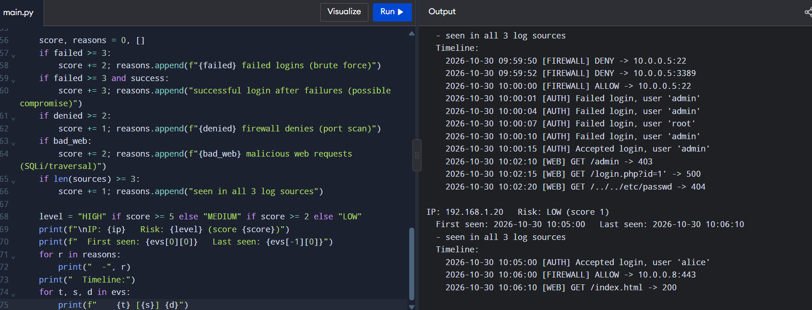
EXPERIMENT 2
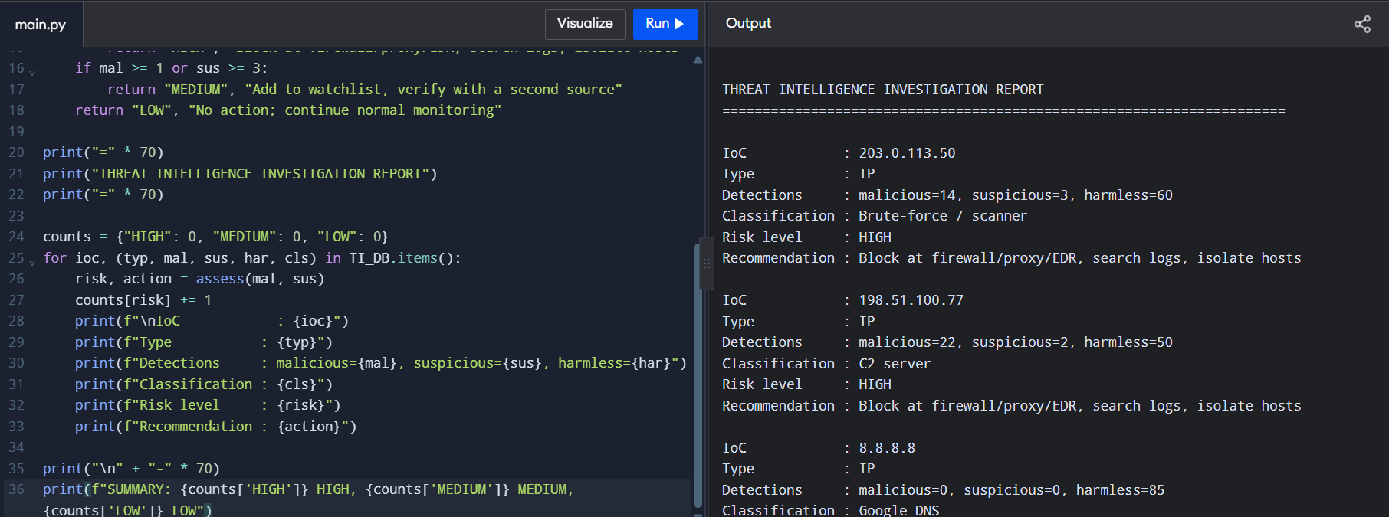

EXPERIMENT3
